**ASSIGNMENT 16.3**

**Problem Statement:**

Execute Session 16 - Assignment 1 (Machine and Sensor data analysis) using Reduce side join and compare which join is faster in normal conditions.

**Input Data Set:**

<https://github.com/prateekATacadgild/DatasetsForCognizant/blob/master/Sensor%20data-20161205T052506Z.zip>

**Program:**

**Driver Class:**

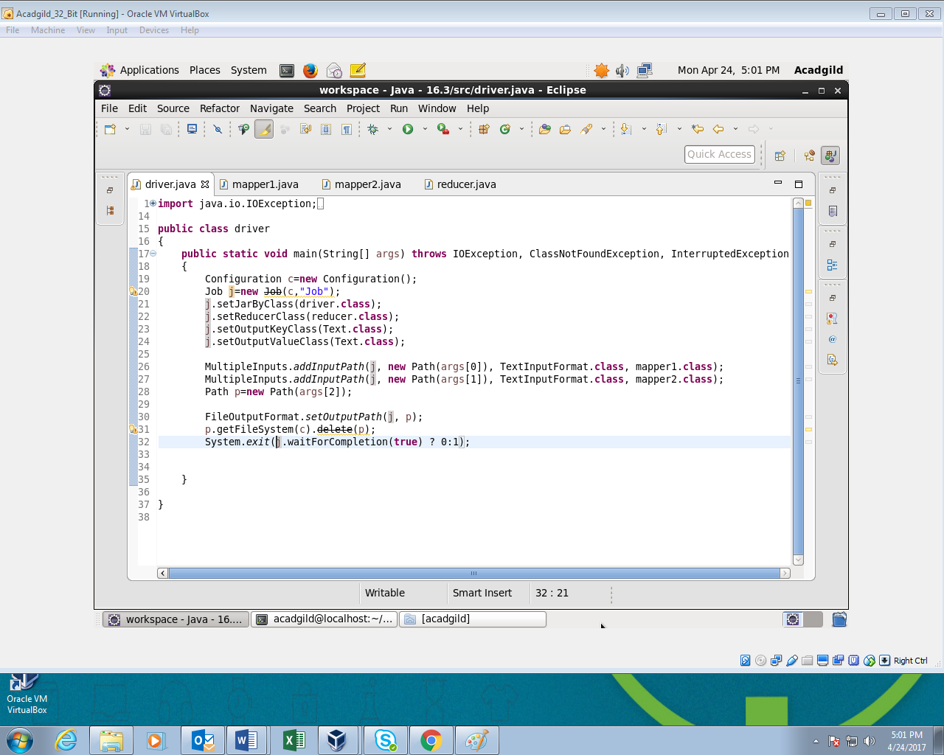

**Mapper 1 Class:**

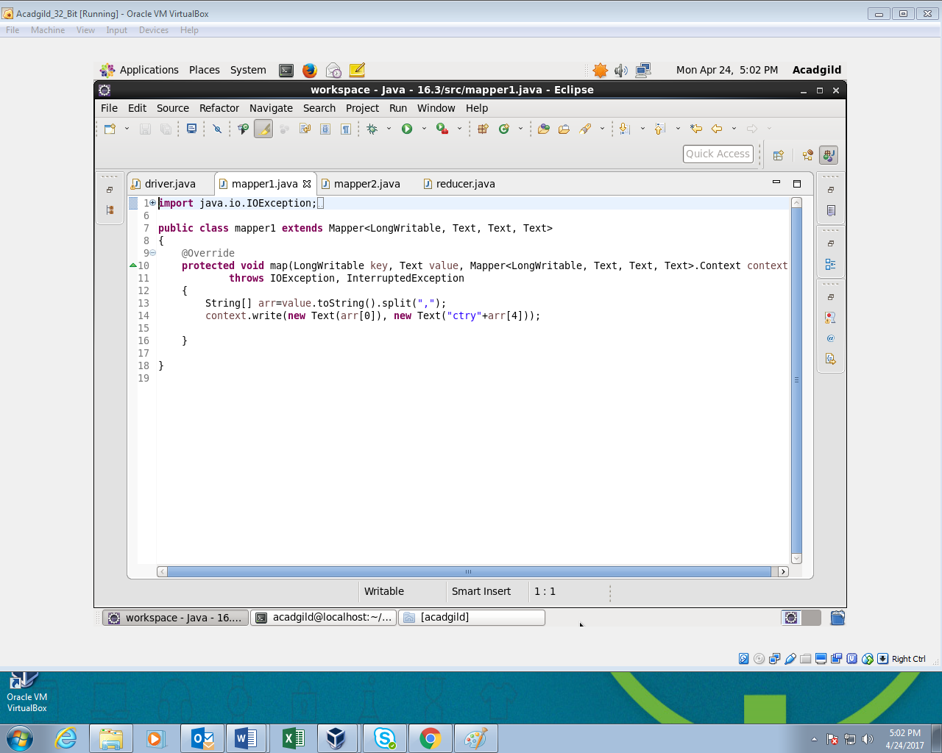

**Mapper 2 Class:**

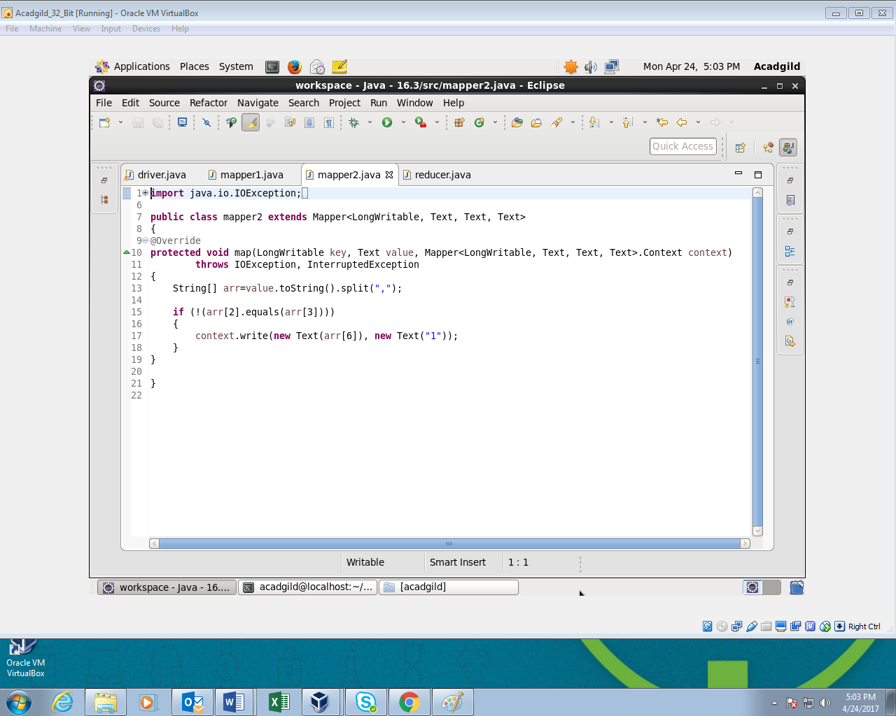

**Reducer Class:**

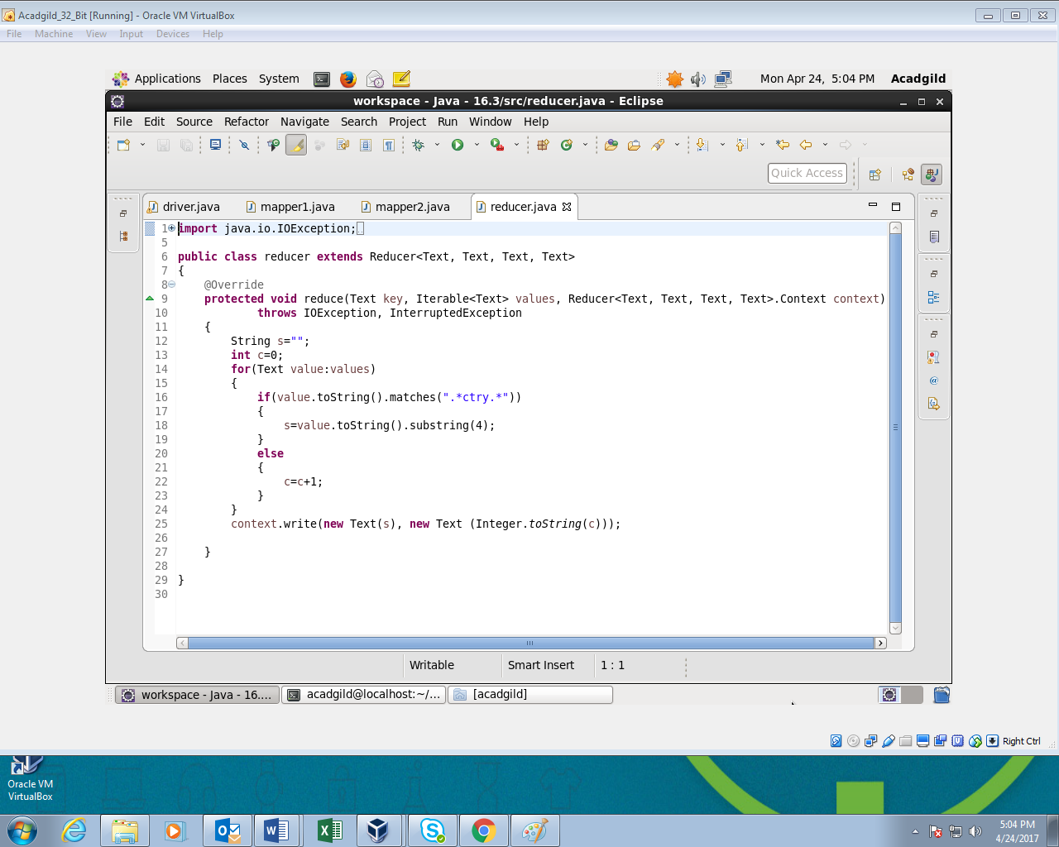

**Output:**

